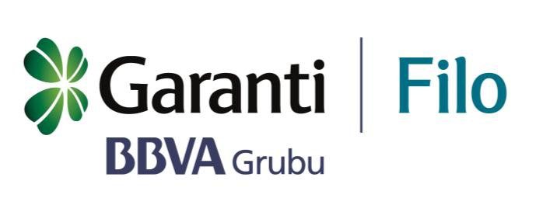Ethics and

Integrity Committee

Ethics and Integrity Committee

Committee Structure
Garanti Filo Yönetim Hizmetleri A.Ş. (Company) Ethics and Integrity Committee (Committee) is an internal body established under the provisions of the Ethics and Integrity Principles (Ethical Principles) approved by the Board of Directors.
Scope of Authority of the Committee
The Committee carries out its duties and responsibilities before the Company and in its branches.
Role and Responsibilities of the Committee
The Committee is one of the fundamental elements of the Company's compliance system of which main objective is corporate ethics and integrity, and which constitutes organizational measures (policies, procedures, internal controls, human resources and materials).
The main objectives of the compliance system are as follows:
- To help all employees and managers understand and interpret the Ethical Principles correctly.

- Identifying deficiencies in procedures and internal controls that may put the group's ethics and integrity at risk and encourage their resolution.

- Fulfilling effective controls over compliance with the criteria and rules in the Ethical Principles.

- Effectively managing the solution of ethical conflicts that may arise during the Company's activities and taking the necessary measures.
Within the scope of the purposes outlined above, the following roles and responsibilities specified below have been attributed to the Committee, which is an element of the Company's compliance system:
- To encourage taking appropriate measures to resolve ethically suspicious actions.
- To report to the following authorities urgently regarding the events and situations that may pose a risk for the company:
- Audit Committee
- Person responsible for the preparation of the financial statements

- To follow up on the actions decided in the Committee meetings.
- To resolve conflicts of interest, especially between the Company and its customers.
- To make authorizations for the exemptions in compliance with certain provisions of the Ethical Principles. It must be ensured that such exemptions do not pose a risk to ethics and integrity principles and are exceptional.
- To develop and disseminate the explanatory notes for ensuring the implementation of the Ethical Principles.
- To make offers of change in the content of the Ethical Principles in order to comply with changing activities and best practices of the financial sector.
- Overseeing the effective functioning of the Affiliate's Ethics and Integrity Committees.
- To ensure the efficient operation of the Ethics Hotline.
The existence of the Committee does not mean that the powers granted to other organs or functions of the Company, which have executive powers in their respective fields, have been assumed by the Committee. (Such as the Discipline Committee)
Committee Participants
The Committee will consist of the following members:
- Ayşegül GÜLGÖR - General Manager
- Gözde MİDİLLİOĞLU - Deputy Loans and Operation Manager
- Sinan PANAYIRCI - Deputy Sales and Marketing Manager
- Tolga ÖZKUL – Deputy Finance Manager
- Ferhat DAL - Internal Audit Unit Manager
- Ceylan ORMAN - Secretariat / Internal Control & Compliance Officer
Committee members gain membership status as a result of their duties and when they leave their positions in the corresponding area, their membership of the Committee ends.
In cases where committee members cannot attend the meetings, they may appoint a manager from their own fields as a proxy for representation. In such cases, they may also appoint another member of the Committee as their proxy.
The Committee will attend the meetings without voting rights.
Role and Responsibilities of the Committee Members
In order to fulfill the functions attributed to the Committee, the following functions and responsibilities are assigned to the members:
- In all cases where they think their content should be discussed in the Committee, ethically suspicious actions (where they are informed about their duties, any communication channel or regulatory authorities) may present to the attention of the Committee,
The Committee Members that have knowledge of the ethically suspected case, firstly, are required to report to the Compliance Department for the creation of the right record and then, to report to the Committee, when necessary. In this context, the relevant Committee member collects the necessary information and makes the necessary investigations done in the relevant fields. Confidentiality should be maintained during this process.
- Submitting to the Committee, in line with the current legal framework, of all developments in the fields they have been assigned to represent where they consider that the content should be discussed in the Committee and where they think may pose a risk to the ethics and integrity principles of Garanti.
- Supporting studies that encourage the implementation of the Ethical Principles, especially in cases where there is doubt in the interpretation or when complementary studies are required.
- Informing the Committee about changing commercial activities and best practices in the long-run car rental sector that may require amendment in the Code of Ethics or the content of this regulation.
Meetings
The Committee should meet twice a year or as many times as necessary to fulfill its functions.
The meetings are held by the Committee Secretariat or on the Committee's own initiative or at the initiative of any member if it’s one of the regular meetings.
In the event that all its members or their representatives take the place in the Committee, the Committee shall have been properly convened.
In order to evaluate the issues to be discussed properly, persons who are considered to be beneficial may be invited to the meetings by the Committee.
Only the Committee members or their representatives and the Committee Secretary take part in the making of the final decisions.
Decision Making
The decisions and solutions of the Committee must be accepted by the majority.
Functions of the Secretariat
The Committee Secretariat will perform the following functions:
- Calling for the Committee.
- Preparation of the agenda and proposals related to the Committee meetings in such a manner that will be delivered to all members.
Recording the observations and agreed decisions during the committee meetings, and distributing the results to all members; at the same time, sending the relevant decisions to other organs and managers of the Company who are required to be informed about their content.
Functions of the Compliance Officer
Following up the actions arising from the decisions of the Committee as well as regularly reporting their development and current status are the responsibilities of the Compliance Officer.

