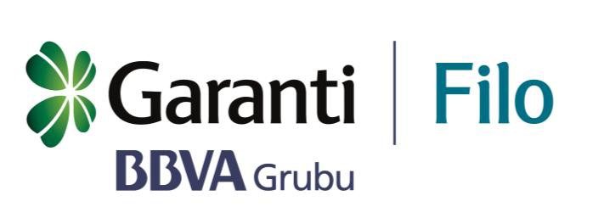Audit

Committee

Audit Committee

Purpose of the Committee
Garanti Filo Yönetim Hizmetleri A.Ş. (Company) Audit Committee (Committee); was established to assist the Board of Directors in fulfilling its oversight duty regarding the functioning and effectiveness of the company's internal control system.
The committee reviews and evaluates the company's system, process and activities and, if required, makes suggestions to the Board of Directors in a specialized and focused way on the issues of;
- Accounting system, financial reporting and public disclosure,
- Internal control and internal audit system,
- Independent external audit,
- Compliance with laws, regulations and ethical principles.
Committee’s Powers and Responsibilities
- The Committee is formed and authorized by the Board of Directors. The Committee acts within its own authority and responsibility and makes recommendations to the Board of Directors.
- The Committee is empowered to receive information by inviting company employees or representatives of persons and organizations associated with the company, internal and external auditors and experts in their fields to its meetings and to obtain professional outsourced consultancy when needed. It is essential that company employees cooperate and contribute to the Committee when deemed necessary by the Committee.
- The Committee creates communication channels that will provide the personnel of the units within the scope of internal systems are able to contact with it directly.
Organization and Working Method of the Committee
Membership
- The Audit Committee is formed based on the provisions specified in the relevant legislation and the Company's Internal Directive.
How it works
- The Audit Committee convenes at least four times a year.

- Company directors and employees are invited to meetings when deemed necessary. In addition, the Committee may request the internal auditors, independent auditors and the internal control officer to make a presentation to the Committee when necessary.

- Results of the Committee meetings are recorded in minutes and kept regularly. The Board of Directors is informed as specified in the relevant legislation.

Duties of the Committee
Internal Control System
- The Committee evaluates whether the company management shares the importance of internal control with the company employees and whether a correct "control culture" has established in the company.

- The Committee receives information about the results of the periodic and process-oriented reviews carried out by the Internal Audit Unit and Internal Control Officer regarding implementation errors and deficiencies.

- The Committee monitors the deficiencies detected after the audit actions carried out by the Internal Audit Unit, Internal Control Officer T. Garanti Bankası A.Ş Inspection Board and other institutions and informs the Board of Directors of the findings that have not been remedied.

Internal Audit
- The Committee supervises whether the Internal Audit Unit fulfills its obligations specified in the Internal Audit Regulation.

- The Committee reviews the annual audit plan prepared by the Internal Audit Unit and the revisions made in the annual audit plan before the approval of the Board of Directors.

- It approves the appointments of Internal Audit and Internal Control personnel. It reviews the Internal Audit Unit Regulation and the Internal Control Regulation before they are approved by the Board of Directors.

- It makes the performance evaluation of the Internal Audit Manager and Internal Control Officer. In this regard, when necessary, it may receive the opinions of the Company General Manager.

- The Committee monitors the decisions taken by the senior management and the units affiliated to them regarding the issues identified in the internal audit reports and internal control recommendations.

- The Committee evaluates the activity report of the Internal Audit Unit and the reports submitted to the Committee and including the results and evaluations of the monitoring activities of the Internal Control Officer.

- The Committee monitors the competence of the Internal Audit and Internal Control staff structure and the current education, competence and expertise levels of the internal audit and control personnel; and takes the necessary measures to train internal audit and control employees in the best way in theory and practice.

Financial Reporting and Independent External Audit
- The Committee monitors whether the financial reports of the company include all true and required information, whether it is prepared in accordance with the Law and other relevant legislation, and ensures that any errors and irregularities detected are corrected.

- The selection of the independent audit firm, the preparation of audit contracts and the initiation of the independent audit process, and the action of the independent audit firm at all stages are carried out under the supervision of the Committee.

Compliance with Law, Regulation and Ethical Principles
- The Committee observes the operation of internal systems as well as accounting and reporting systems within the framework of laws and related regulations and also the integrity of the information produced.

- The Committee reviews the Company's activities through its units with regard to compliance with laws and regulations.

- The Committee monitors whether the internal policies and implementation procedures approved by the Board of Directors are followed and makes recommendations to the Board of Directors regarding the necessary measures to be taken.

The committee’s duties and working principles and the amendments hereon come into force on the date approved by the Company Board of Directors. The amendments in the new Audit Committee regulation were approved by the Board of Directors on 21.06.2017.

